Microsoft logo

Robotic Process Automation in a Day

Lab prerequisites 1.2 – Create a browser profile

10 mins

April 2023

Applies to Power Automate Desktop v. 2.31.105.23101 ([more](https://learn.microsoft.com/en-us/power-platform/released-versions/power-automate-desktop))



This document is provided “as-is.” Information and views expressed in this document, including URL and other Internet Web site references, may change without notice. You bear the risk of  
using it. Some examples are fictitious and are for illustration only. No real association is intended  
or inferred. This document does not provide you with any legal rights to any intellectual property in any Microsoft product. You may copy and use this document for your internal reference purposes.

© 2021 Microsoft Corporation. All rights reserved.

Pre-requisite task: Create a profile in your browser (optional)

**Note:** The aim of a new web browser profile is to prevent you from being signed out from your existing work or school Account. If you will be doing labs using your **existing work or school account**, feel free to skip this lab.

To create a new profile, follow the steps below.

If using Microsoft Edge

1. In the address bar type: edge://settings/profiles
2. Now click “+ Add profile”
3. Confirm creation of the new profile

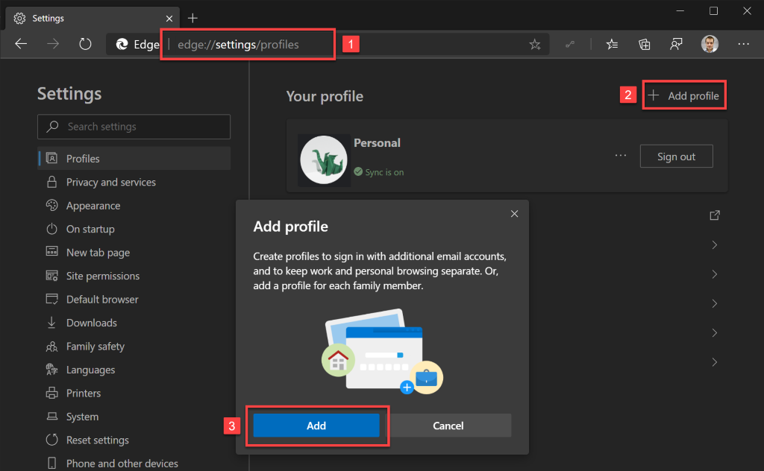

1. Once the new profile is created, browser will automatically open a new window with that profile active.
2. In the new window, if you again go to the URL from the point no. 1, you will be able to customize your profile, e.g. give it a name or set an icon.

If using Google Chrome

1. Click the avatar icon that you can find in the top-right corner
2. Then in the expanded menu click “+ Add”

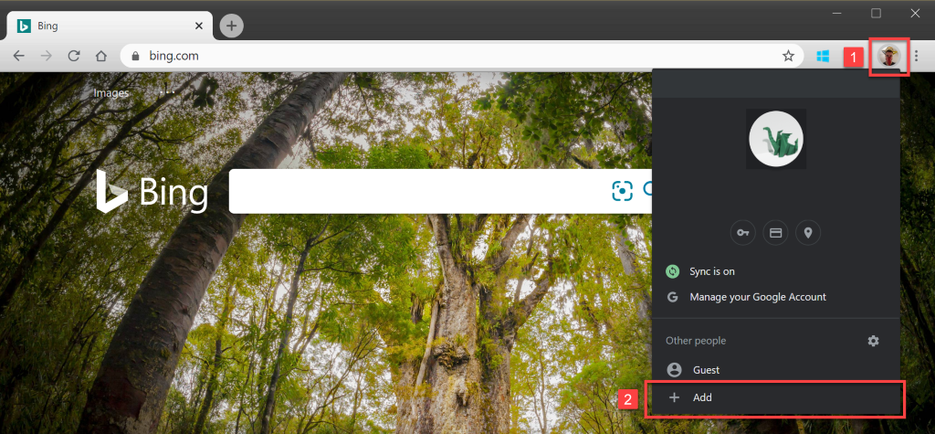

1. Now set a name for the profile
2. Pick an icon
3. Uncheck (or leave checked) option to create a desktop shortcut for the new profile
4. Hit “Add” button

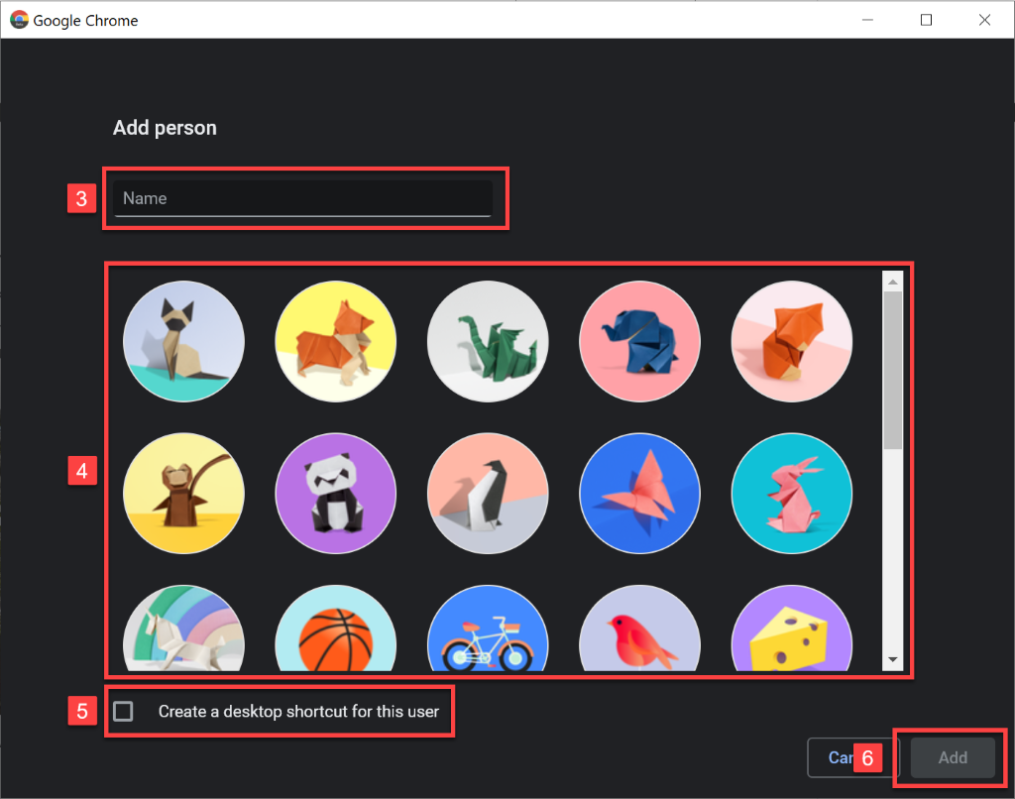

1. Once the new profile is created, browser will automatically open a new window with that profile active.

Important: From now on, all the steps in Labs should be done using this newly created profiles.

Information in this document, including URL and other Internet Web site references,  
is subject to change without notice. Unless otherwise noted, the example companies, organizations, products, domain names, e-mail addresses, logos, people, places, and events depicted herein are fictitious, and no association with any real company, organization, product, domain name, e-mail address, logo, person, place or event is intended or should be inferred. Complying with all applicable copyright laws is the responsibility of the user. Without limiting the rights under copyright, no part of this document may be reproduced, stored in or introduced into a retrieval system, or transmitted in any form or by any means (electronic, mechanical, photocopying, recording, or otherwise), or for any purpose, without the express written permission of Microsoft Corporation.

Microsoft may have patents, patent applications, trademarks, copyrights, or other intellectual property rights covering subject matter in this document. Except as expressly provided in any written license agreement from Microsoft, the furnishing of this document does not give you any license to these patents, trademarks, copyrights, or other intellectual property.

The names of manufacturers, products, or URLs are provided for informational purposes only and Microsoft makes no representations or warranties, either expressed, implied, or statutory, regarding these manufacturers or the use of the products with any Microsoft technologies.  
The inclusion of a manufacturer or product does not imply endorsement of Microsoft of the manufacturer or product. Links may be provided to third party sites. Such sites are not under the control of Microsoft and Microsoft is not responsible for the contents of any linked site or any link contained in a linked site, or any changes or updates to such sites. Microsoft is not responsible for webcasting or any other form of transmission received from any linked site. Microsoft is providing these links to you only as a convenience, and the inclusion of any link does not imply endorsement of Microsoft of the site or the products contained therein.

© 2021 Microsoft Corporation. All rights reserved.

Microsoft and the trademarks listed at <https://www.microsoft.com/enus/legal/intellectualproperty/Trademarks/Usage/General.aspx>are trademarks of the Microsoft group of companies. All other trademarks are property of their respective owners.